AZURE VIRTUAL MACHINE
- An Azure Virtual Machine (VM) is a virtual server hosted in Microsoft Azure.
- It can be used to run Linux or windows operating systems and applications.
STEP1: Open Azure Portal
Sign in to the Azure Portal and select virtual machines from the Azure services or search bar.
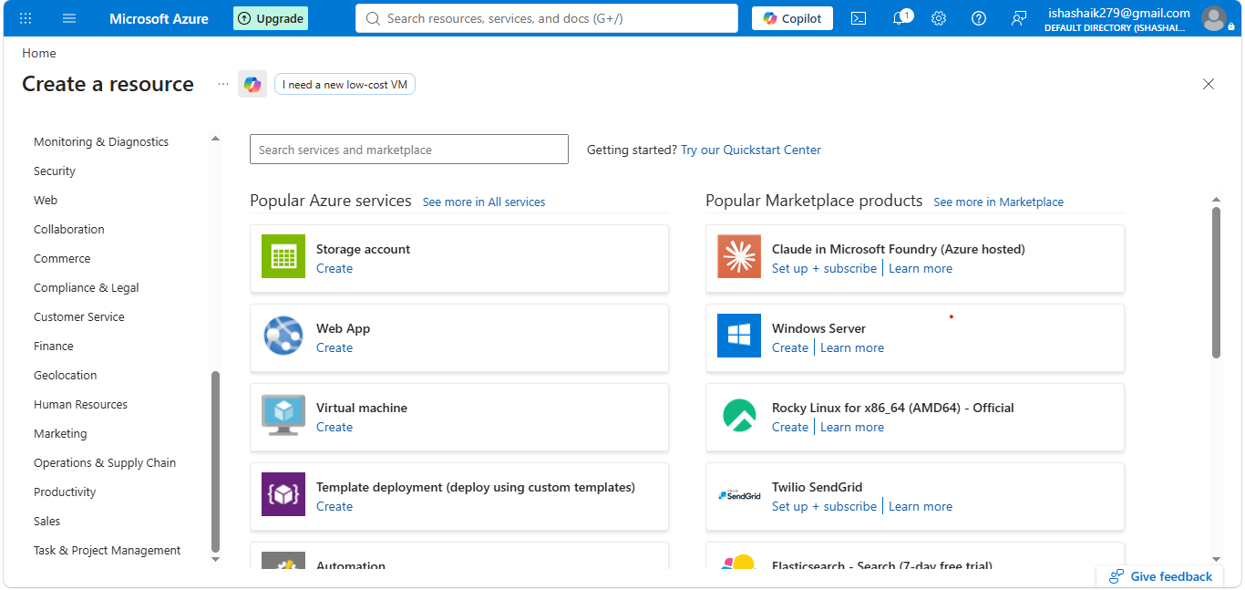
STEP2:Create Virtual Machine
Select Create Azure virtual machine. Choose the required subscription and resource group.
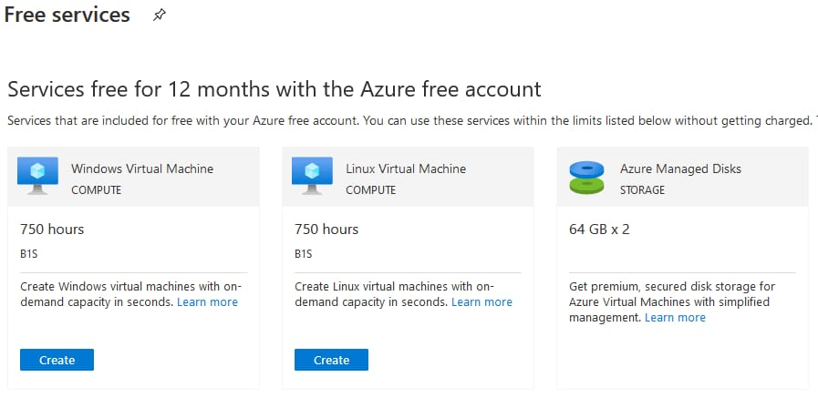
STEP3: Configure Basics
Enter the VM name, select the required region, availability option, operating system image, and authentication method. For this sample, East US and Ubuntu server are used.
Subscription: select Azure subscription
Resource group: Create new resource group Ex: cloudrg

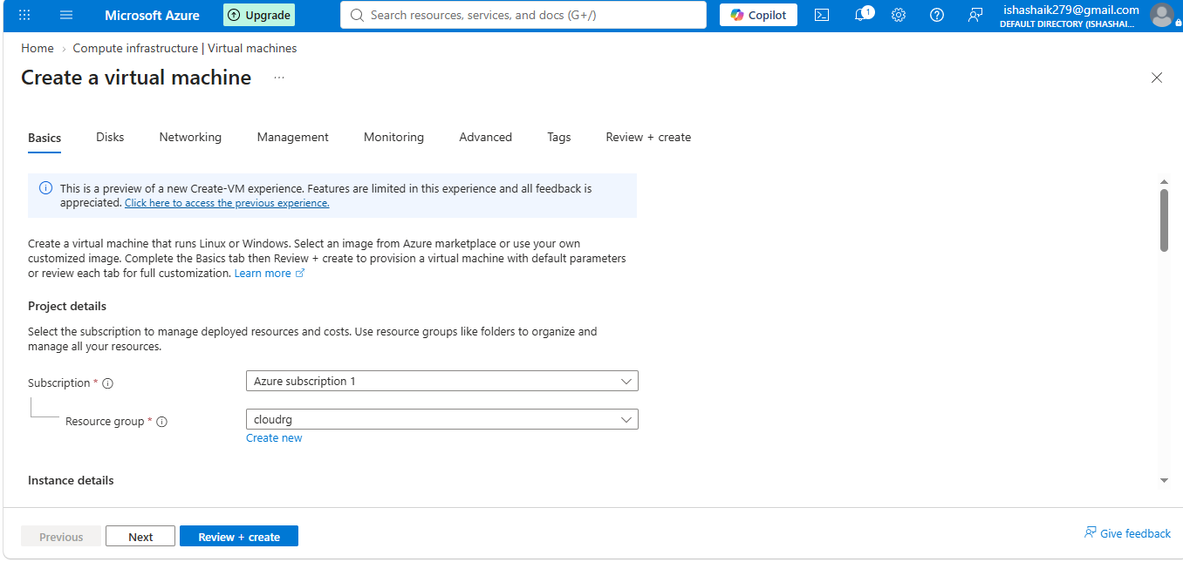
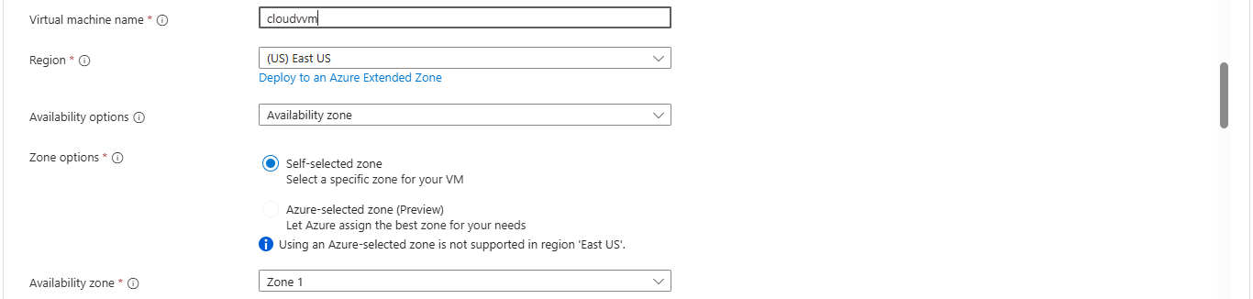
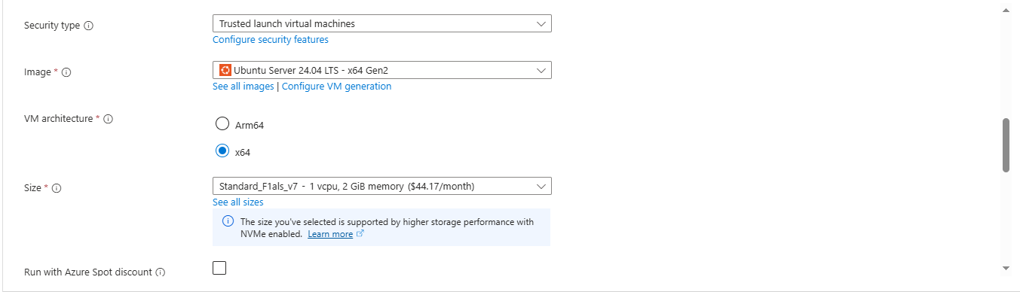
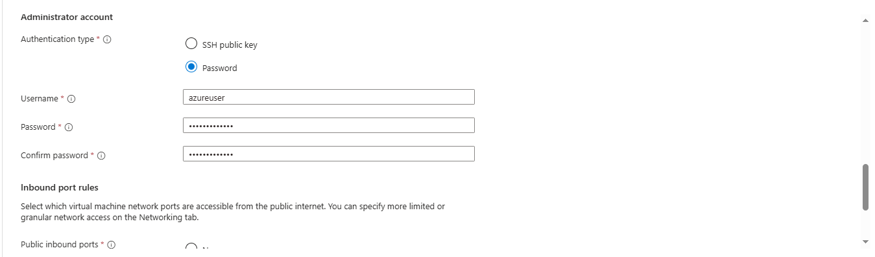
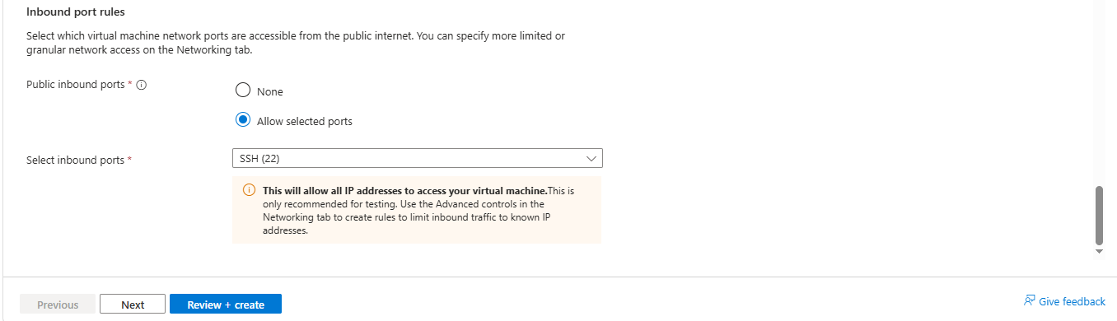
STEP4: Authentication
For Linux VM:
- Authentication type: SSH public key
- Enter a username.
- Generate or provide an SSH key pair.
For Windows VM, we normally use a username and password.
Purpose: Authentication protects the VM from unauthorized access.
STEP5: Configure Disk
- OS Disk: Stores the operating system.
- Data Disk: Used for application or additional data.
1.Click Create and attach a new disk.
2. Select the required disk type and size.
3.Save the configuration.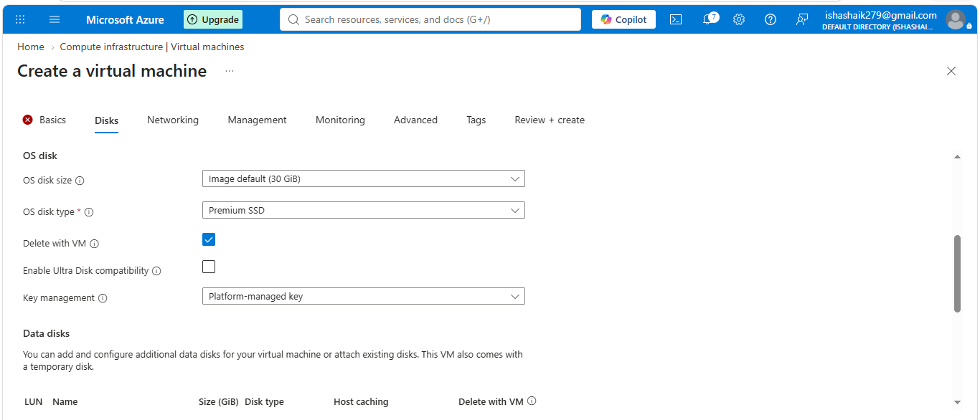
STEP6: Networking
Virtual Network(VNET)Subnetpublic ipNSG
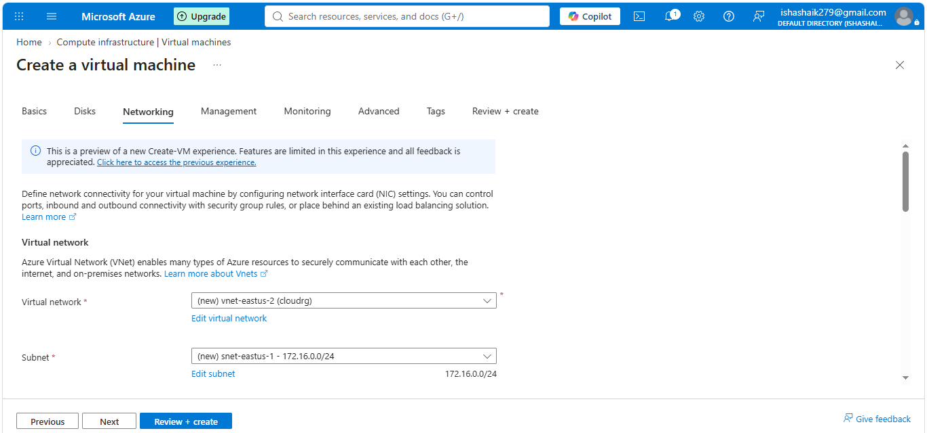
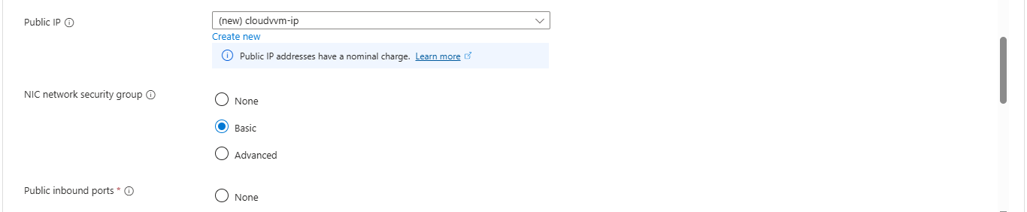
STEP7: Management and Monitoring
May see options such as:
Monitoring, Auto-shutdown, Boot diagnostics
STEP8: Review + create
This is the final confirmation before Azure deploys the VM
STEP8: wait for deployment
Azure will create the required resources
STEP9: Check VM overview
Azure PortalVirtual machineVM
The public IP can be used to connect to the VM from outside the Azure network, when the required network rules permit it.
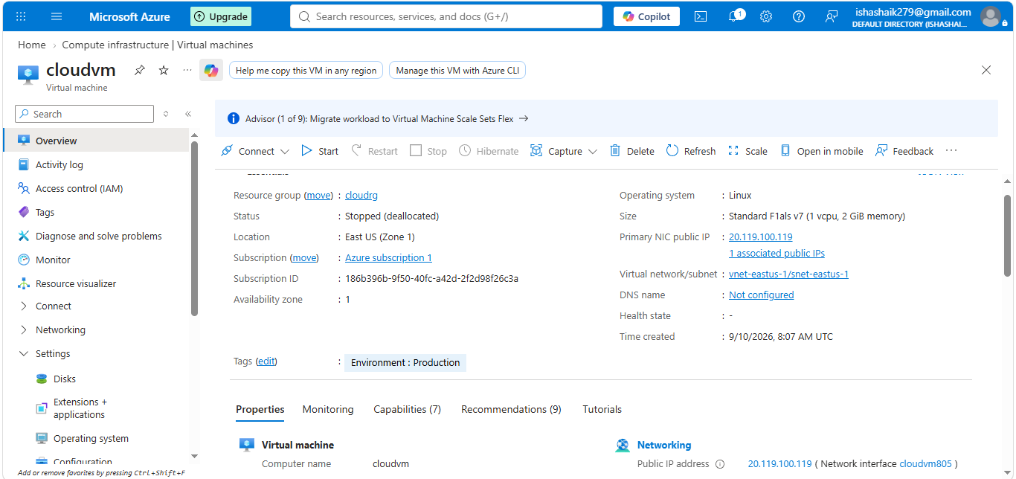
STEP 10: Connect to the VM
connect using SSH:
ssh username@public-ip
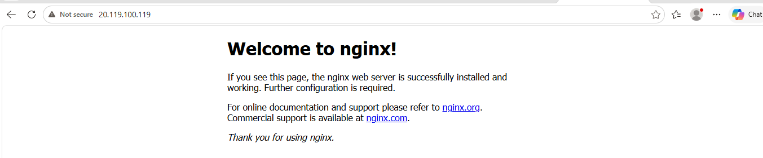

Storage Account
An Azure Storage Account is a container in Microsoft Azure that provides a place to store and manage data in the cloud.
Create an Azure Storage Account — Step by Step
Step 1 — Open Azure Portal
Open:
Azure Portal
Sign in with your Microsoft/Azure account.
need an active Azure subscription to create the storage account
Step 2 — Search for Storage Accounts
After signing in:
- At the top of the Azure Portal, find the Search box.
- Type Storage accounts.
- Select Storage accounts from the results.

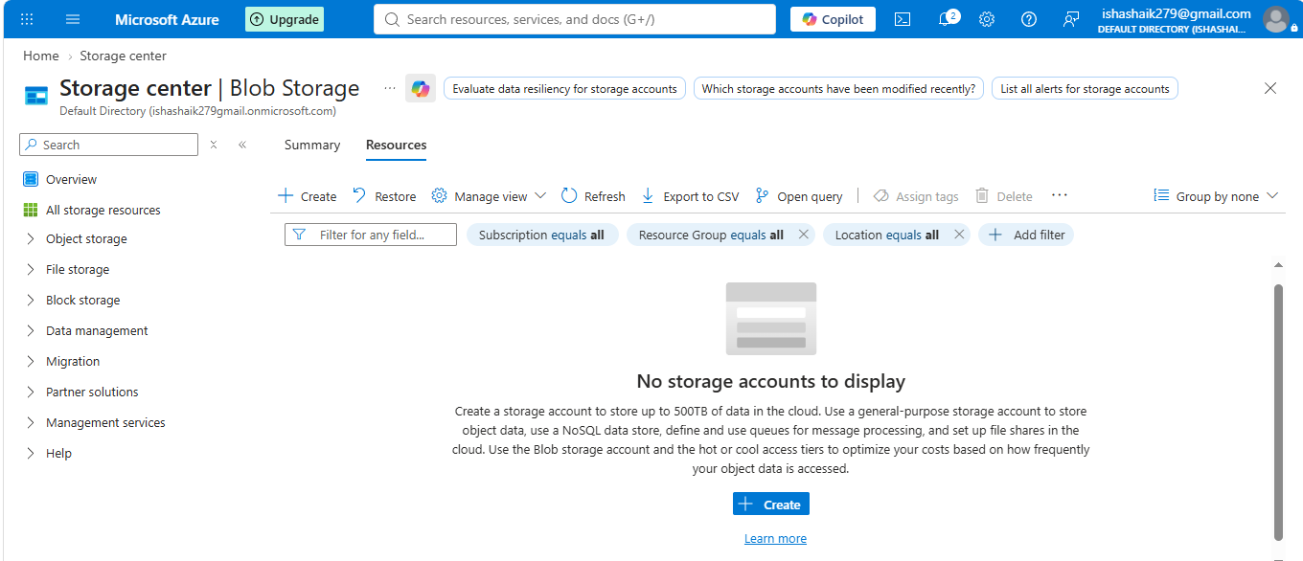
Step 3 — Click + Create
You should now see the Storage accounts page.
